Personal Development Assembly (Class and RE - Hall)

DATE | Link |  | Book
Wk 1  Celebration Day: Sept 5th | Welcome Back (linked to NO Outsiders)  Kindle |  | 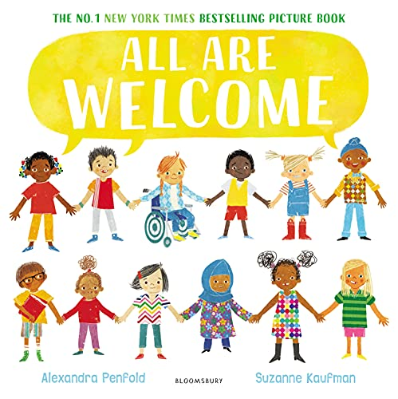
Wk 2  Celebration Day: Sept 14th | National Coding Week  Kindle |  | 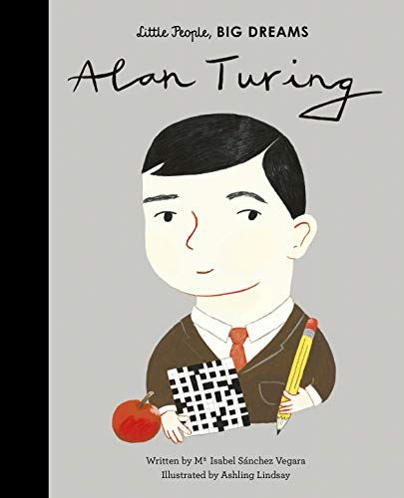
Wk 2  RE  Jo | Harvest Festival |  | Powerpoint  CBBC Video Clips
Wk 3  Celebration Day: Sept 21st | International Day of Peace  Kindle |  | 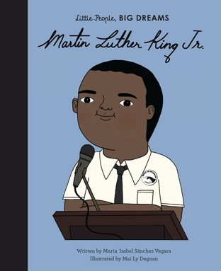
Wk 4  Celebration Day: Sept 28th | World Alzheimer’s Day |  | 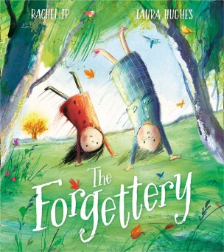
Wk 4  Charlotte | Judaism  Yom Kippur – Day of Atonement  4th – 5th October |  | Saying sorry: Jonah and the Whale - BBC Teach  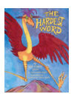
Wk 5 | Black History Month  Kindle |  | 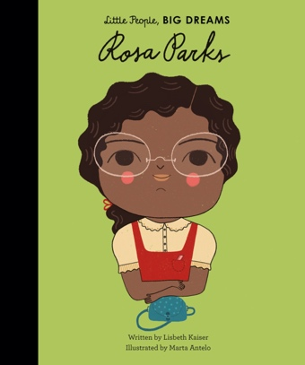
Wk 6  Celebration Day: October 10th | World Mental Health Day  Kindle |  | 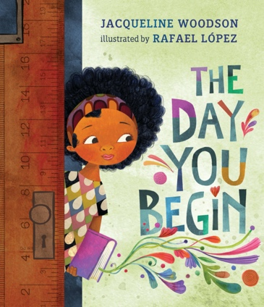
Wk 6  Becky | Hinduism  Festival of Lights  24th October |  | Diwali - the festival of light - BBC Teach  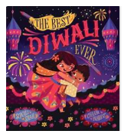
Wk 7  Celebration Day: October 17th | One World Week (Poverty and Homelessness Day)  Kindle |  | 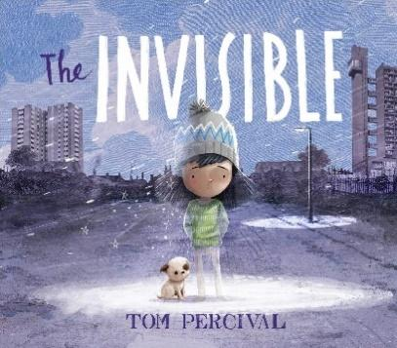
HALF TERM
Wk 1  Celebration Day: November 2nd | Downs Syndrome Awareness Month  Kindle |  | 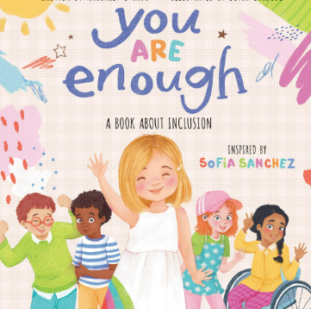
Wk 1  Jo | Sikhism  Importance of Guru Nanak  Birthday 8th November |  | The Birthday of Guru Nanak - BBC Teach  Sikhism - Values for living - BBC Teach
Wk 2  Celebration Day: November 11th | Remembrance Day  Kindle |  | 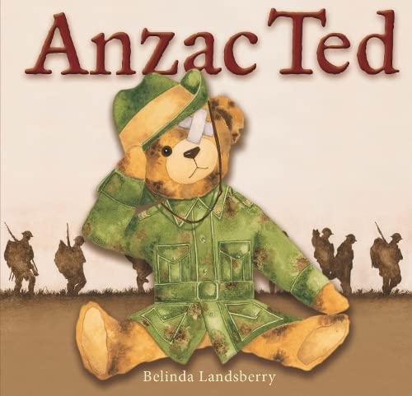
Wk 3 | Anti-Bullying Week  Kindle |  | 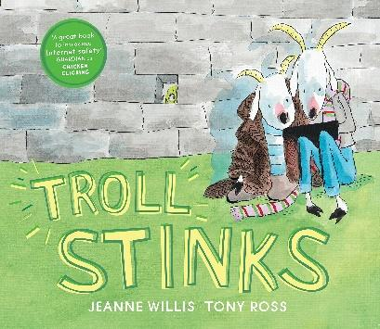
Wk 3  Charlotte | Interfaith Week  13th – 21st November | Inter Faith Week
Wk 4  Celebration Day: November 20th | Universal Children’s Day |  | 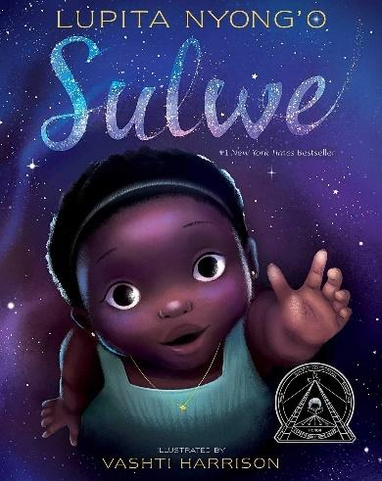
Wk 5  Celebration Day: December 2nd | International Day for the Abolition of Slavery  Kindle |  | 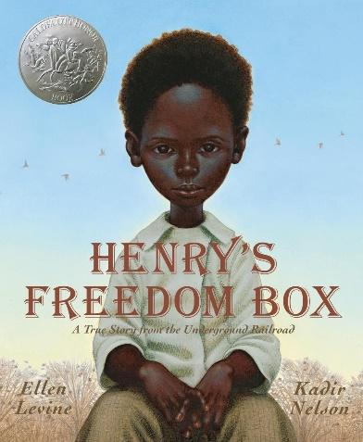
Wk 5  Becky | Judaism  Hanukkah – Jewish Festival of Light | The story of Hanukkah - BBC Teach  Hanukkah - BBC Teach  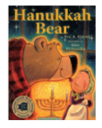
Wk 6  Celebration Day: December 7th | International Day for Persons with Disabilities (03.12) |  | 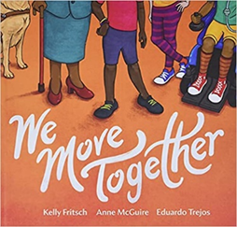
Wk 7  Celebration Day: December 14th | International Migrants Day |  | 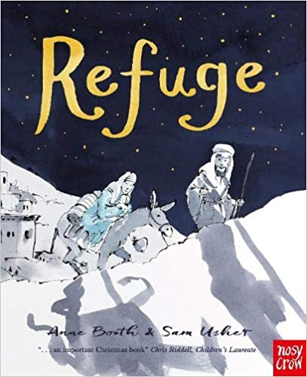
XMAS
Wk 1 | No assembly this week (INSET)
Wk 2  Celebration Day:  Jan 11th | Martin Luther King Jr Day (15.01)  Kindle |  | 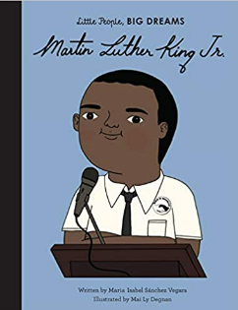
Wk 2  18th Jan  J0 | Chinese New Year | Chinese New Year - BBC Teach
Wk 3  Jan 18th | National Thesaurus Day |  | 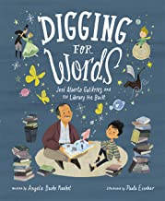
Wk 4  Jan 25th | Holocaust Memorial Day (27.01)  Kindle |  | 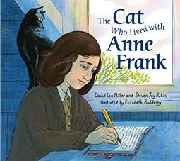
Wk 4  1st Feb  Holly | Christianity  Valentine’s Day | St Valentine's Day - BBC Teach
Wk 5  Feb 1st | LGBTQ+ History Month  Kindle |  | 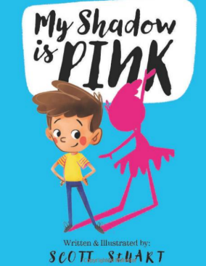
Wk 6  Feb 8th | Children’s Mental Health Week  Kindle
Wk 6  15th Feb  Chris | Christianity  Festival of Lent  Shrove Tuesday, Ash Wednesday | Primary assemblies: The Festival of Lent - BBC Teach
Wk 7  Feb 13th | National Random Acts of Kindness Day  Kindle |  | 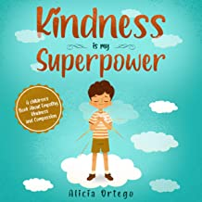
Half Term
Wk 1  Mon 27th February | World Hearing Day  (3rd March)  Kindle |  | 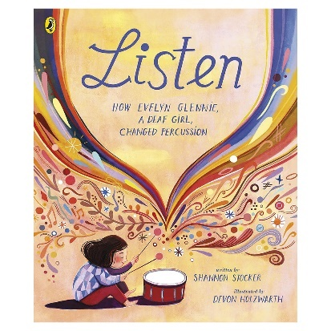
WK 2  Mon 6th March | International Women’s Day  (8th March)  Choose an inspirational person to share with your children. |  | 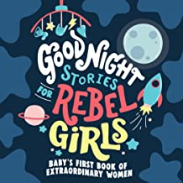
Wk 2  8th March  Charlotte | Hinduism  Holi Festival | Holi - BBC Teach
Wk 3  Mon 13th March | Science Week  Assembly by JP
Wk 4  Mon 20th March | World Water Day  Click on the link below for a PDF version of the text.  https://abbeyroadprimary.co.uk/wp-content/uploads/2020/06/Literacy-Day-2-Once-upon-a-raindrop-book.pdf |  | 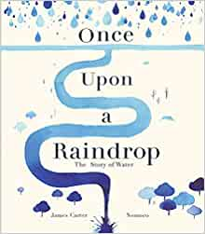
Wk 4  22nd March  Becky | Islam  Ramadan / Islam | Ramadan and Eid - BBC Teach  Ramadan and Eid ul Fitr - BBC Teach
Wk 5  Mon 27th March | Autism Awareness Week |  | 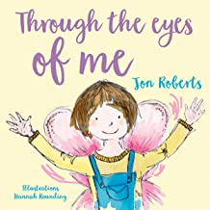
Easter

