Little Leigh Primary School
Policy for Attendance and Punctuality
Policy approved November 2020
Policy to be reviewed November 2022

Little Leigh Primary School and Create Learning Trust recognise that children need to attend school in order to receive their educational entitlement and to make the most of that education. Children with regular absence miss continuity of teaching leading to their achievement and progress being impaired. Children regularly arriving late have their education, and that of their peers, interrupted. This has a negative impact on the positive start to the day we want for all children.

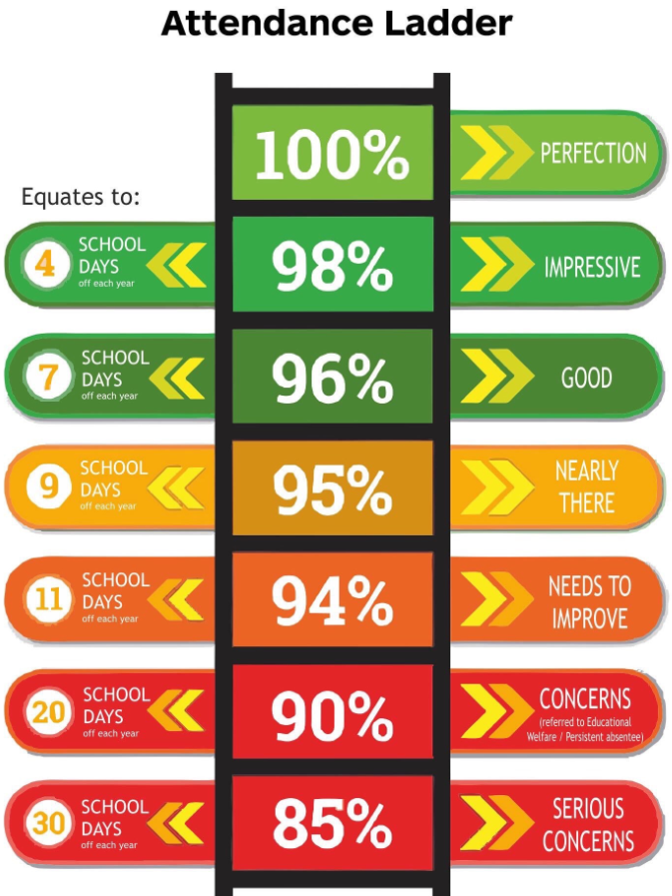
Rightly, parents and carers hold the school to account for the quality of education provided. Likewise the school will hold parents to account for supporting their child’s learning which includes ensuring that they come to school promptly each day and do not take time off school without legitimate reason. An attendance rate of 90% equates to a half day absence a week and is unacceptable. An attendance rate of 95% (equivalent to a full day absence every four weeks) is deemed ‘persistent absence’ by the school and Department of Education. Parents will be challenged if a child’s punctuality or attendance falls below the good standard we expect.

The Head of School has very limited authority to authorise absence in term time. School attendance is required by law in the UK, unauthorised absence is, strictly speaking, breaking law. Unauthorised absence may, in some circumstances, result in the school requesting that the Local Authority issue a fixed penalty notice. Parents and carers should note that the governors and Headteacher aim to avoid the use of fixed penalty notices and that the school does not receive any monies from the issuing of a fine. Please refer to the School’s Policy for ‘Leave of Absence’ requests.

We seek to work in partnership with all families and this involves honest and respectful relationships. While the Headteacher is unable to authorise all absence requested, honesty will always be respected; likewise it is expected that the school’s decision is respected. We do not condone any family teaching their child that lying and cheating is a way for good citizens to behave.

Guidelines
Children’s attendance and punctuality is overseen by the Head of School and Local Academy Board supported by the Local Authority’s Attendance Officer. The school is aware that poor attendance can be an indicator of a safeguarding concern and other vulnerabilities. Poor attendance without good reason constitutes neglect in that it fails to support a child’s right to an education, to develop and thrive. The school will challenge all poor and persistent absence. The attendance officer will monitor the attendance of all children at least termly and bring to the Head of School's attention any child falling below 95%.

Where there is a safeguarding concern, the Head of School may request that she is notified of unexplained absence from school on the first day.
Attendance is monitored throughout the year. Letters are sent to parents and carers of persistent absentees and late children. The first letter is informal and for information. In managing attendance, we are mindful of the time of year, an absence in September has a greater impact on the overall percentage than absence in July.

Should attendance not improve after the first letter, further correspondence uses the Local Authority’s documentation updated in Spring 2018. Parents may be expected to attend an attendance panel: a meeting with the Headteacher where they can outline how they will support future good attendance. Targets may be set.

Families who continue to fail to improve their child’s attendance will be asked to meet with the Headteacher and Family Support Worker again and help draw up a plan which will include targets for improvement.
By law, children are required to start school full time the term after they turn five. Nevertheless, once a family has applied for a place at Little Leigh Primary School and their child is on roll with us, we expect the same good attendance as we would for any other child.

1 PUNCTUALITY
The school doors open at 8.30am, indicating that children can come into school. Class doors are secured at 9.00am. Children arriving after that time must come into school via the main entrance and are marked late before register closes, they receive a mark for the session.

The register is recorded at 9:05 and at 9.15 the register is closed. Children arriving after this time must sign in at the main office and are marked absent for the whole of the first session (morning). The afternoon register is taken at 12:40pm in key stage 1 and 1:05pm in key stage 2.
Parents of children who are persistently late will be contacted, in person, by telephone or letter, reminding them of the importance of attending school on time. Failure to improve the situation will result in parents being asked into school to discuss their difficulties in arriving in school on time and consider how we might help. Punctuality targets will be set.

2 ABSENCE
Parents are asked to telephone on the morning of the first day of absence. Where the school has not been informed of a reason for absence reasonable attempts will be made to contact home.
It is parents’ and carers’ responsibility to ensure that our records of their current telephone numbers, address and e-mail are up to date.
Parents asking for Leave of Absence for any reason other than medical, must do so in writing (using a form provided by the school office), in advance. Letters should state the purpose of the absence and the exceptional reason for them wanting to take it in term time.

All leave of absence is at the Head of School's discretion. The Head of School will make that decision in line with the latest guidance from the Local Authority and Department of Education. She will apply discretion fairly and without fear or favour.

Families are expected to take their annual holidays in school holidays. In exceptional circumstances an event may require term time absence. Examples of where a term time absence might be authorised include: armed forces staff returning to a tour of duty; critical illness of a close family member; specific funeral rites to be attended to.

If an employer does not permit annual leave to be taken in school holidays the school requires written confirmation of company policy before considering authorising any leave of absence.
In making a decision as to whether to authorise leave of absence, the Head of School will consider:
the nature of the absence, e.g. an unavoidable family event, parent unable to take holiday in holidays due to exceptional circumstances (e.g. as armed forces personnel returning to active service, funerals); attendance rates - this and previous years; any exceptional medical circumstances which have resulted in unavoidable poor attendance (e.g. confirmed by medical professionals); previous years’ attendance and any previous taking of unauthorised term time holiday.

The Head of School will provide a reason for any decision to authorise a term time absence. We do not provide reasons where the request for absence has been declined as this is usual policy.
Absences are not be authorised for family celebrations such as birthdays and weddings.
Any teacher or other adult working in school who is concerned about any child’s attendance should communicate this to the Family Support Worker, or Head of School.

The Family Support Worker and admin staff are supported by the LA Educational Welfare Officer in monitoring attendance. From January 2018 the Education Welfare Service will retain statutory duties of register checks and children missing from education but will not undertake casework and supporting families with poor attendance directly.

The Head of School has the right to refer term time absence for a Fixed Penalty Notice should the criteria in the CWaC School Attendance - Guidance and Pathways to Statutory Legal Intervention be triggered. Should a child be absent from school and all attempts to contact the parents and carers (including the emergency phone numbers) have proved unsuccessful, the school will undertake a home visit. This will take place, if possible, no later than the second day of absence.

After three days of unexplained absence, the school will inform the Local Authority (e.g. the Education Welfare Officer or colleagues in social care) and take advice in order that information may be circulated, if necessary to social care or police should the child be suspected as missing from education or at risk of harm.

Where a child in a ‘vulnerable group’ (e.g. there are safeguarding concerns, there is a Team Around the Family in place, the child is known to social services or in the care of the Local Authority) absent from school without a reason being provided will result in the school contacting colleagues in the Safeguarding Children in Education [SCIE] team or colleagues in social care by lunchtime on the first day of absence.

3 CHILDREN MOVING SCHOOL
Parents are required to provide the school with the name and address of the school to which the children are moving. The school will contact the receiving school and make them aware of any relevant information that should be shared, e.g. Disability and Special Educational Needs [DSEN] or Safeguarding information.

When children move to Little Leigh Primary School, we will contact the previous school to confirm the child’s registration with us and to ask if there is any relevant information to be shared.

If children move school without notifying us in advance, we will refer their name/s and last known address to the Education Welfare Service as a child missing from education. This information can then be shared nationally in order for services to ascertain a family’s whereabouts and ensure the safety of children.

4 EQUALITY AND ACCESSIBILITY
Children with very specific medical needs, preventing good attendance at school, will have this taken into account in managing attendance and where a request for exceptional additional leave is requested. Where children have exceptional medical needs, they may arrive late more often. Registration time may be adjusted at the discretion of the head teacher e.g. a child with diabetes whose parent or carer needs to ensure blood sugar levels are acceptable before bringing into school.

Teachers will provide school work to be completed at home under exceptional circumstances where a child’s medical condition necessitates a prolonged absence from school and whose parents or carers request it. Work will be provided for short term absences or term time absence whether authorised or not.

Requests in advance for absence to participate in religious festivals will be authorised if the absence is exclusively set apart for religious observance. The school may seek advice and clarification from the relevant religious body.

Requests for visiting family abroad outside the normal school holiday will be respected (although they cannot be authorised) as long as a child’s general attendance is 98% and above.

We work to avoid and minimise any emotionally based school non-attendance [EBSN].

